Name: ___________________

B O M

O B O

Name: ___________________

M B O

O B M

Name: ___________________

M B O

O S M

Name: ___________________

M B O

O S M
S M O

Name: ___________________

A B O

B S M
S M A

Name: ___________________

S B A

O S M
A B O

Name: ___________________ Date: _________________

O S M M

A M M S

M A O S

B B B M

Name: ___________________ Date: _________________

O S M B

B A A B

S O B A

A M A M

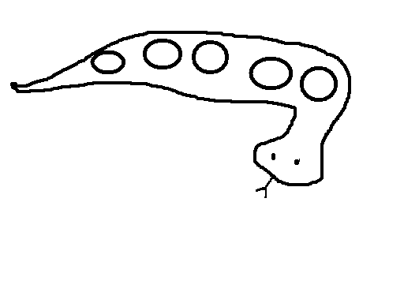
Name: ___________________ Date: _________________

A B S O

M M S M

B O B S

A B A T

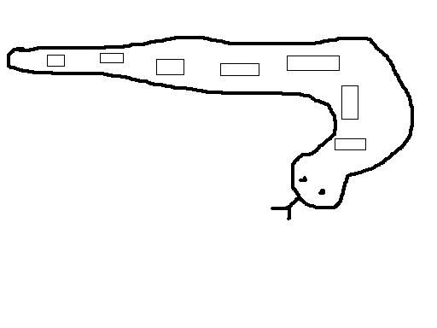

Name: ___________________ Date: _________________

O S M T

B A A B

S A O B

M A M A

Name: ___________________ Date: _________________

O B A S

M S A A

A A T A

B A B A

S O B A

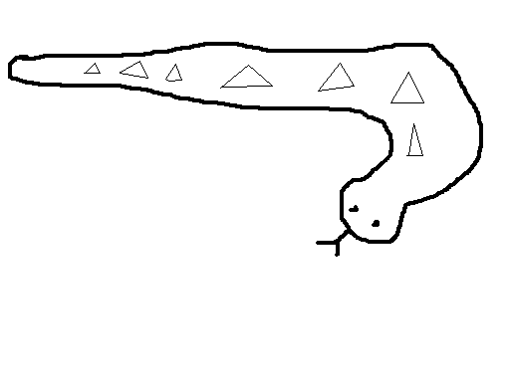
Name: ___________________ Date: _________________

O S M T

A B S O

M A M A

A B A A

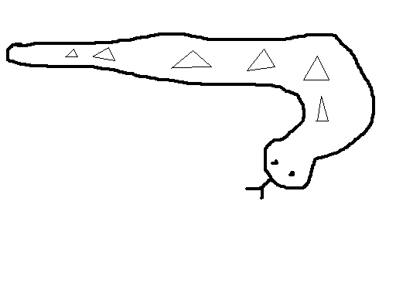
Name: ___________________ Date: _________________

S A M O

A B T S

T A M B

T E E A

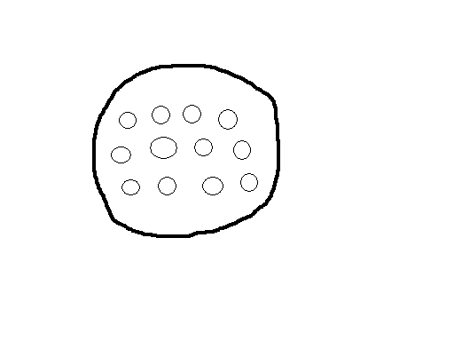
Name: ___________________ Date: _________________

M A A O

M B A A

S M O A

A A S T

M B B B

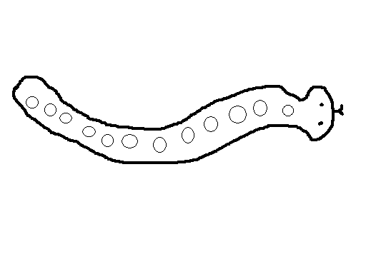

Name: ___________________ Date: _________________

S A M O

B A A B

T S T A

B E C C

E E T S

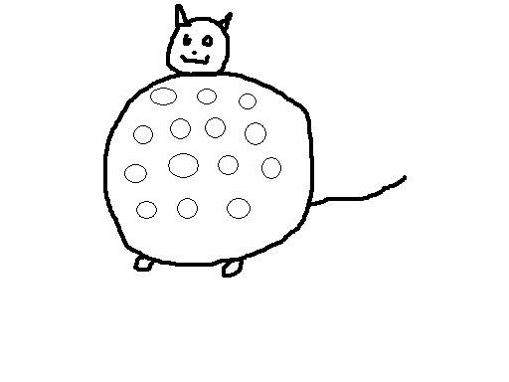
Name: ___________________ Date: _________________

S A M T O
A A C C B

T S M B A

C C C E E

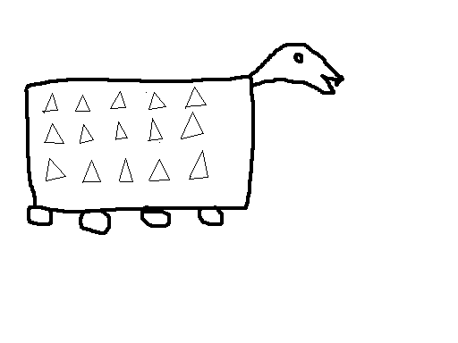
Name: ___________________ Date: _________________

S A M T

C B O C

C S A A

E C E E

C T A B

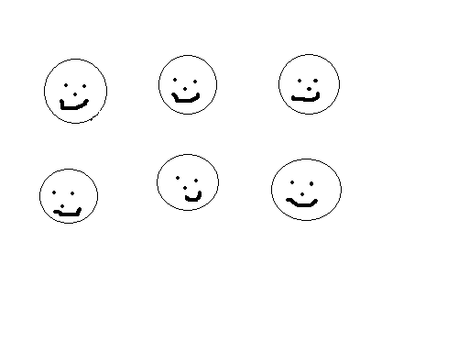
Name: ___________________ Date: _________________

S A M B

E C T O

D C B A

E D D C

T O D C

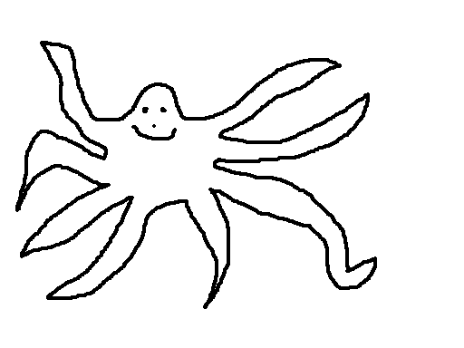
Count the tentacles (arms)
Name: ___________________ Date: _________________

S A M O B
E T A B O

D C E C A

B D T O M

a a a a a
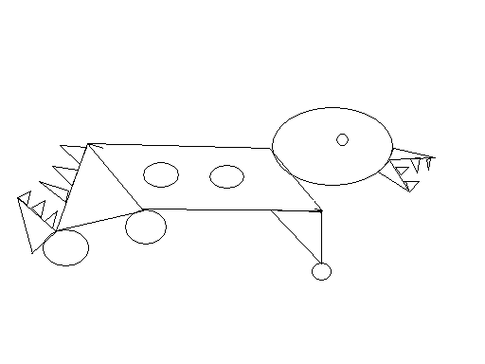
See any triangles? Point to them. Circles? Optional: tilted rectangle making up most of body is “sort of a rectangle, but tilted, so it is not really a rectangle (Highly optional: it is a “parallelogram”)
Name: ___________________ Date: _________________

S A M O
A B C D

E M C T W
W R A E

C e a e

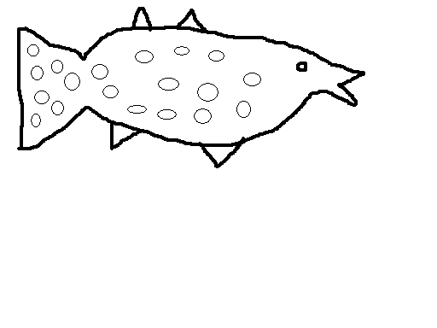
Some of the circles are squished. “Ovals.” Count them all. See any triangles?
Name: ___________________ Date: _________________

S A M a B
R W T e C

E B D M A

R a e P R

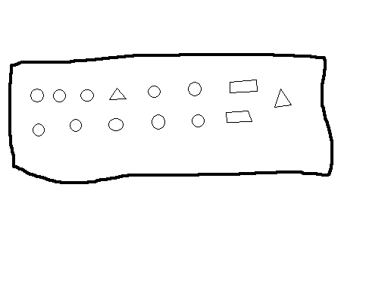
What are the different shapes? Count each shape.
Name: ___________________ Date: _________________

S A M B
T a R E C

C P a A
D E W T

a R R B

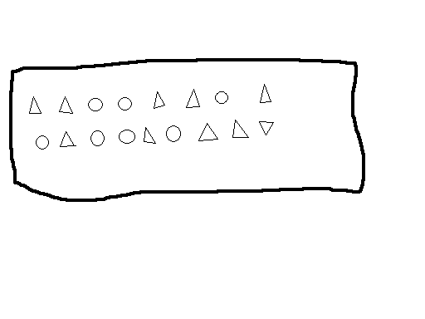
Count the triangles. Now count the circles.
Name: ___________________ Date: _________________

S A M B C
O W R C E

a T R C e
D a R a

e E a C

blast off
Name: ___________________ Date: _________________

S A M B e
a E C R T

W e D E M
O P a e e

1 2 3
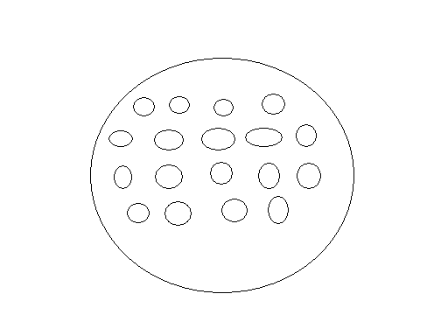
Are some of these not very good circles? “Ovals.” Count them all – circles and ovals.

blast off
Name: ___________________ Date: _________________

S A M D
B C E P

a O N W
e L R T

1 2 3

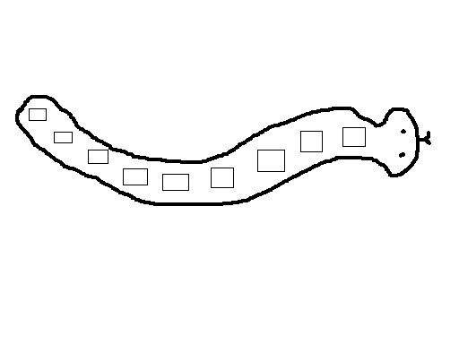
Name: ___________________ Date: _________________

S A M B
R a E C

D T e O
L P M R

N W i A

1 2 3
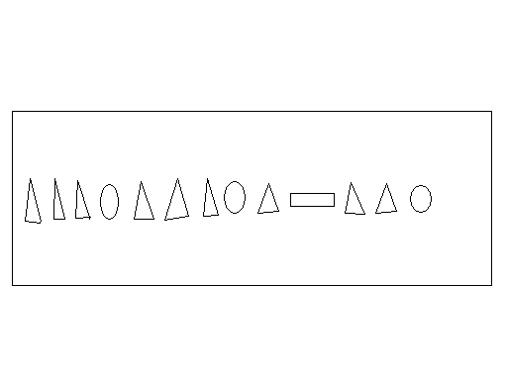
Count the triangles. What are the other shapes?

blast off
Name: ___________________ Date: _________________

S A M a e
C D B L

W R a P
E e L N

T e a B

1 2 3
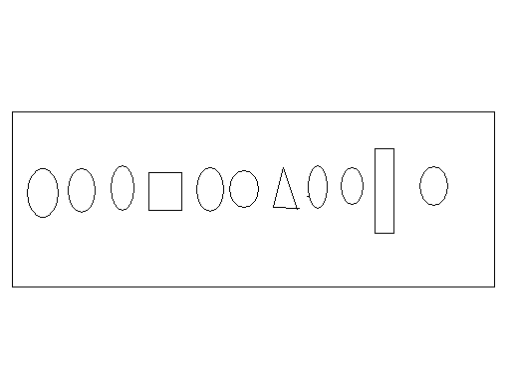
Count the circles. What are the other shapes? (note – there are no squares, just circles, triangles and rectangles)

blast off
Name: ___________________ Date: _________________

S A M B
N O C a

e P D E
i L W R

T e a i

1 3 2
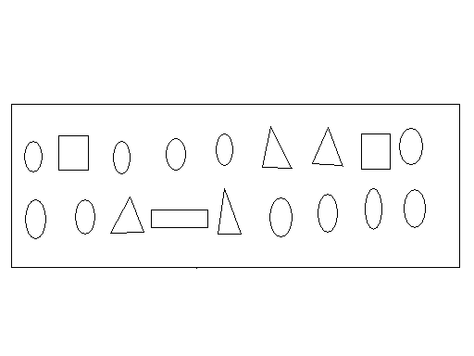
Count the circles. Rectangles. Triangles.

blast off
Name: ___________________ Date: _________________

S A M C

B a i e

O U W N
P R T E

e a i o

D B P R

3 1 2
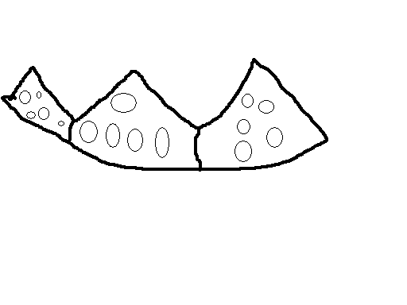
How many circles in each section? How many in all? Are some of the circles a little weird?

blast off
Name: ___________________ Date: _________________

S A M e

B D P a

R T C L
E i W O

N a e i

3 2 1
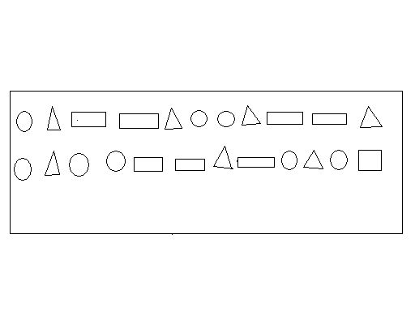
How many circles? Rectangles? Triangles? How many shapes in all?

blast off
Name: ___________________ Date: _________________

S A M a R

O B D E C

a L N I P
T V W Y e

Vowels: ____________________

3 2 1
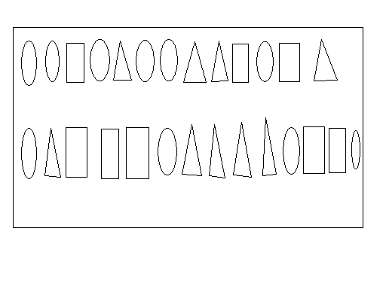
How many circles? Rectangles? Triangles? How many shapes in all?

blast off
Name: _______________________
________________ Date: _________________

S A M R B

a e i o P

C D E L N
T W a e L

1 2 3 4
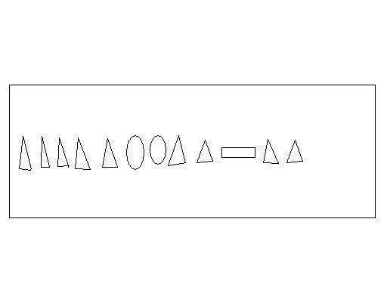
Vowels:
blast off
Name: ___________________ Date: _________________

S A M D D

L P a R

B C e L
i a E c

N O T W

1 3 4 2

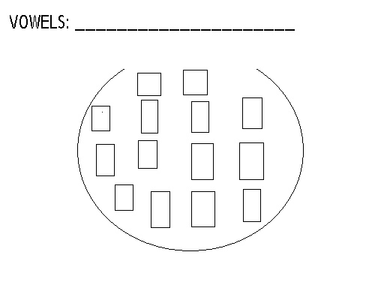
blast off
Name: ___________________ Age: _________________

S a m e L i

c a t w u R

1 2 S a m
+ 1 + 1
2 3

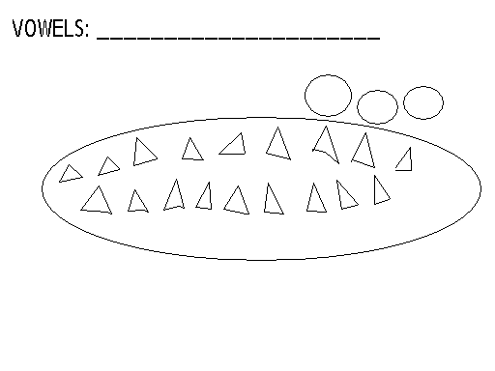
blast off
Name: ___________________ Date: _________________

S a m B L

R e o t i u

C E D N P A
W a o i e u

3 4 1 2

Vowels:_____________________

Cat

blast off
Name: ___________________ Date: _________________

S a m B e i

D c E L o A

P R t s u N
W m a e i

3 5 2 1 4

cat 1
+1

Vowels:_____________________

blast off

Name: ___________________ Date: _________________

S a m o B D

R e a i c E

H I L N P S
T u v w y i

6 2 1 4 5 3

Vowels:_____________________
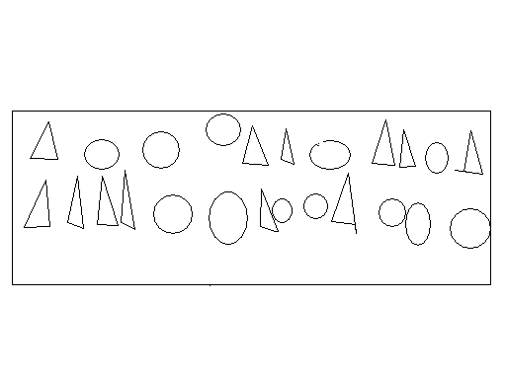

blast off
Name: ___________________ Date: _________________

S a m i p R

t a e c o u

B W R D Y
E a H L N

3 1 4 2 5 11

Vowels:_____________________
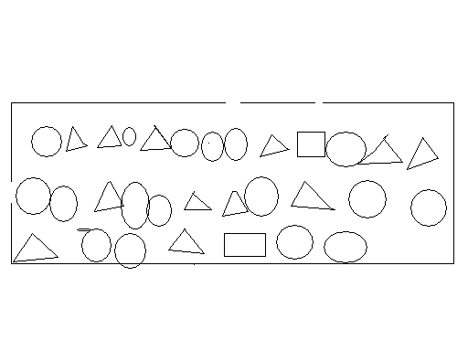

blast off
Name: ___________________ Date: _________________

S a m A B C D

B E B e o B U

L B P B R T B
i b c D B H W

B N r B a e

1 3 5 8 4 2

Vowels:_____________________

blast off

Name: ___________________ Date: _________________

e L B c D H

i a w s A M

N R P E G o
T u x y r
2 1 0 3 4 5

6 8 7 4 6 7

Vowels:_____________________

cat fat 2
+ 2 blast off
Name: ___________________ Date: _________________

a c L B S A T

M R W u r i E

D E U F G W H

N P o X
1 6 2 3 5 8 4

2 cat hat
+ 1

Vowels:_____________________

blast off

Name: ___________________ Age: _________________

a i B e s o u

c y w D e x

H L P N M r

R T t S

5 8 2 4 3 1

Sat 2
+3

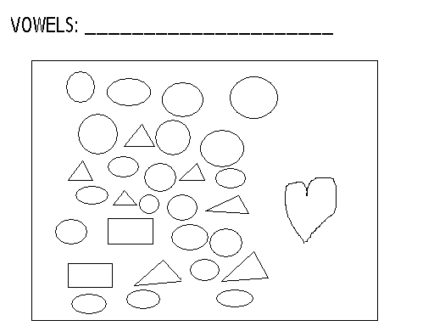

blast off

Name: ___________________ Date: _________________

S a m i p R

t a e c o u

B W R D Y
E a H L N

3 1 4 2 5 11

Vowels:_____________________

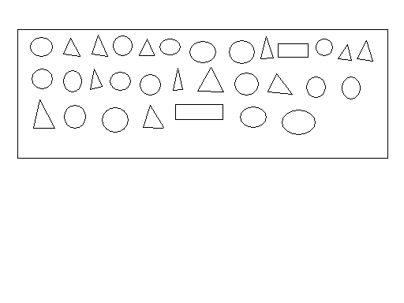
blast off
Name: ___________________ Date: _________________

S a m A B C D

B E B e o B u

L B P B R T B
i B C D B H W

B N r B a e

1 3 5 8 4 2

Vowels:_____________________

blast off

Name: ___________________ Date: _________________

e L B C D H

i a W S A M

N R P E G O
T U X y r

2 1 0 3 4 5

6 8 7 4 6 7

Vowels:_____________________

C a t F a t 2
+2

blast off
Name: ___________________ Date: _________________

a c L B S A T

M R W u r i E

D E U F G W H
N P O X

1 6 2 3 5 8 4

2
+1 c a t h a t

Vowels:_____________________

blast off

Name: ___________________ Date: _________________

a i B e s o u

c y w D E X

H L P N M r
R T t s

5 8 2 4 3 1 2 + 3=
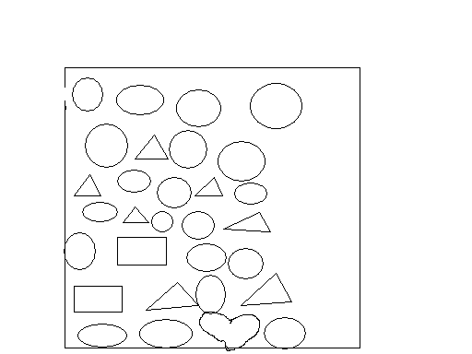Sat

Vowels:_____________________

blast off

Name: _____________ Date____________________

U W L R a T H

i o S e P B E

C M D A y r g G
5 8 6 3 1 4 2

2 3 2 2 +1 +1 +2 +3

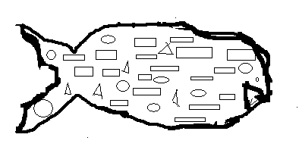

Vowels_________________________ Blast Off!

Name: ___________________ Date: _________________

W x a c y D e

F G H P R i L

T S M o N u v
5 2 1 8 3 4

cat fat 1+3=

2+2= 3+2=

Vowels:_____________________

blast off

Name: ___________________ Date: _________________

a L X W B Y

C D S e T F

u G V H R E
r i p M o N

5 8 3 2 1 4 0 6

6 6 6 6 _ _ _ 6 9

1 2 Fat Cat
+1 +2

Vowels:_____________________

blast off
Name: ___________________ Date: _________________

B x w N a o L p

Q R c A T S M

D e u E V F G
H i

3 5 6 6 6 2 2 6 2 6

8 4 1 0 6 2 2 6 2 6

1 2 Dog
+3 +0 Cat

Vowels:_____________________

blast off

Name: ___________________ Date: _________________

X L e u v F

D F G H i F

F O G L Q r
r F u F V r

2 6 8 6 4 6 6 10

1 2 5 3
+4 +3 +5 -1

SAT

Vowels:_____________________

Blast off

Name: ___________________ Date: _________________

r y L x G H a B

e r F i Q v x F

F r v r F r R v
8 6 2 6 3 1 6 4 0

1 2 2 3 3
+2 +2 +3 -1 -2

cat hat

Vowels:_____________________
blast off
Name: ___________________ Date: _________________

a c B y w D G e

E S U T F H P

Q i r L R m
O N r F v r v

3 6 8 4 2 6 1 5

1 3 2 4
+2 +1 +2 - 1

Vowels:_____________________

blast off

Name: ___________________ Date: _________________

S a m A Y W B

D X C F U E V G T

R H S i r L p N T
Q o e T

4 3 6 0 5 2 1 7 10

2 3 4 5
+2 +2 +1 - 2

Vowels:_____________________

blast off
Name: ___________________ Date: _________________

I r t N F G H a e T

B D L p Q R u V X

6 1 4 5 3 6 2 8 7

Fat Cat

2 3 4 4 4
+2 +1 +2 - 1 -2

Vowels:_____________________

blast off
Name: ___________________ Date: _________________

S a m o p e i

r v L u B c x

W N x c D E H
G F A t s Q R y

8 6 4 2 1 3 5 7 9

2 3 5 4
+2 +1 -3 - 1

Vowels:_____________________

Fat Cat

blast off
Name: ___________________ Date: _________________

a Z B y C X D

W E A V e F U

f t G S H R i
r L Q M P N O

4 6 3 1 2 5 8 7 10

Fat Cat

3 2 4
+4 +2 - 1

Vowels:_____________________

blast off
Name: ___________________ Date: _________________

f F v u p L r

f e a i s g G

H N A X Z
5 3 6 7 2 1 4 8

2 3 3 5 5
+4 +1 +4 +5 - 2

Fat Cat Hat

Vowels:_____________________

blast off

Name: ___________________ Date: _________________

V L P e a

I r F H

4 3 3
+4 +1 - 1

Name: ___________________ Date: _________________

a z B w c x D

y e u E v F t

f s G r g R H

Q i p L N m o

3 6 4 2 5 8 1 7

Fat Cat Sat

3 5 4 3
+2 +1 -2 -3

Vowels:_____________________

blast off
Name: ___________________ Date: _________________

a e i o u y D z B

r v L H G f b p t

4 6 3 1 2 7 5 0 8 9 10

Fat Cat Sat Sam

1 3 5 4
+4 +5 -2 -0

Vowels:_____________________

blast off

Name: ___________________ Date: _________________

b c a a e i D E Z

f G W F H x y L

N p R t s r b b B
3 6 7 2 8 4 10 5 9 1

3 5 4 fat
+1 +5 - 3 cat
hat
sat

Vowels:_____________________

blast off

Name: ___________________ Date: _________________

Y M M A S y m m a s

K X I J T f m t

O u w R fat mat cat

Fat cat sat on the mat.

3 6 2 10 1 +1 +1

Vowels:_____________________

blast off
Name: ___________________ Date: _________________

b D g j l n p u v 1 2

hop top mop pop

fat pat sat cat 10 8 5

3 0 6 5
+4 +4 -2 -1

Vowels:_____________________

blast off

Name: ___________________ Date: _________________

S a m y b w c A x

Z B r c t D p e Q

E R f o F n g N G

L h l H j i

4 6 3 2 7 8 2 9 10

2 5 8 9 4 3
+4 +5 +3 +2 -1 -3

Vowels:_____________________

blast off
Name: ___________________ Date: _________________

b L k x t h f g w k

r n u V D i k j l Q

3 8 10 2 9 6 4 11 7 5

hat sat rat fat mat tat
ham sam ran fan map tap

8 8 3 4 10
+2 +4 +3 -2 - 2

Vowels:_____________________

blast off
Name: ___________________ Date: _________________

K k l f h x k Q b

hat hot hit

pat pot pit

cat cot

bat bit

2 13 5 10
+9 +5 -3 - 4

Vowels:_____________________

blast off
Name: ___________________ Date: _________________

Q x k T V u M L P Q

3 6 4 5
-3 +2 -2 -1

PAT THE CAT.

I CAN HOP.

I AM SAMMY.

Vowels:_____________________

blast off

Name: ___________________ Date: _________________

K j l u v p k b x r

hat hot hit

top tap tip

the

6 2 9 4
+7 +5 -2 - 3

Name shape and divide in half:

Vowels:_____________________

blast off
Name: ___________________ Date: _________________

x b l m k Q g r i p

I am Sam. I can hop.

the no fat sit

2 2 6 9 3 10
+3 -2 +3 +4 -1 -3
½
¼

Vowels:_____________________

blast off
Name: ___________________ Date: _________________

a B w c e D

O A R m L H

i N P S U T V

5 2 1 3 4 8

1 2
+2 +3

Vowels:_____________________

blast off
Name: ___________________ Date: _________________

b g j k l n u v x

5 8 10 2 4 6 3 1 7 9 11

I am Sam. I can run.

I can hit the ball. I am hot.

I see the cat.

2 4 9 2 1 3
+3 +3 +3 +0 -1 -1
½
⅓⅓⅓

Vowels:_____________________

blast off
Name: ___________________ Date: _________________

B r k l t x u g v h

6 2 1 3 7 9 4 5 8 10 11

100 1 12
2

I am a girl. I can see the cat.

I like cats.

2 4 5 4
+3 +7 -5 -2

Vowels:_____________________

blast off
Name: ___________________ Age: _________________

Write your brother’s name: _______________

Write the name of an animal: ______________

5 8 10 2 4 6 3 1 7 9 11

I am Sam. I am not a cat.

the 3 7 11 10 5 4

2 3 1 2 2
+4 +6 +0 -1 -2

Name each shape then divide in ½:

Vowels:_____________________

blast off
Name: ___________________ Age: _________________

Q K X y T P B u r t

Sam cat sat hat

2 5 2 6 2 6
+3 +1 +2

Name each shape then divide in ½:

The “intersection is the area inside both shapes. Color the intersections red. Color the areas inside only one shape blue:

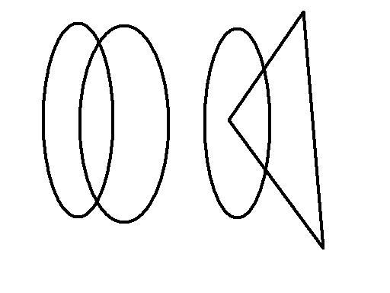

Vowels:_____________________

blast off
Name: ___________________ Date: _________________

a c E f z w y x

D A e u p v b F

Q g r G R s h t H T

i m j N o k L n l

I

3 5 6 8 10 2 1 4 9 11

7 0

I am Sam. I can see the cat.

3 2 3 4 3 2
+2 +4 +3 -1 - 2 -2

Vowels:_____________________

blast off
Name: ___________________ Date: _________________

r n b l p d g h q d p b f v d

6 4 10 7 11 8 12 14 16 18

soap hear coat feet seed

make rope fire coke

5 4 7 8 10 7
+6 -2 +5 +6 - 3 -4

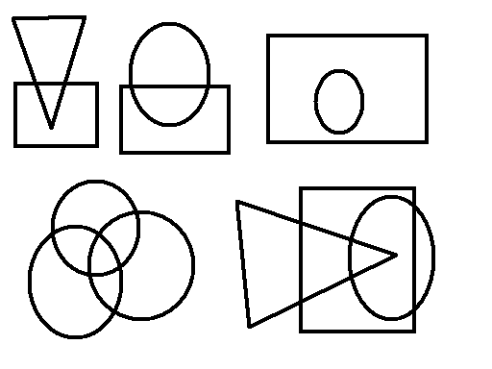
Vowels:_____________________

blast off
Name: ___________________ Date: _________________

see the tea boat

keep heat goat hear

cake coke like

2 10 2 3 10
+7 +4 +0 -1 -3

Vowels:_____________________

blast off

Name: ___________________ Date: _________________

hat fat hot rat

can ham tap top

The cat did not see the dog. The dog said, “Bark!!” The cat ran. Bye-Bye cat.

2 6 3 4 10 8
+4 +3 +0 -0 -1 -8

Vowels:_____________________

blast off

Name: ___________________ Date: _________________

I like to eat meat.
I can eat an apple.

3 6 10 12 11 9 14

2 9 10 2 5 8
+4 +3 +5 -1 -2 -8

Name and divide in half.

Vowels:_____________________

blast off

Name: ___________________ Date: _________________

i r n u f v g h B p

hat hate 6 10 5 11

hop hope 4 9 12 3

car care 16 18 19 20

tap tape 17 14 13 12

I hope the cake is good.

I am hungry.

2 7 0 10 5 6
+5 +6 +3 -4 - 1 -2

Vowels:_____________________

blast off
Name: ___________________ Date: _________________

b q h d b p g l j k b d

12 10 13 14 16 18 19

hear hair rain soak

tape fire lake bite

I can see the big fire.

8 13 9 10
+3 +4 -3 - 4

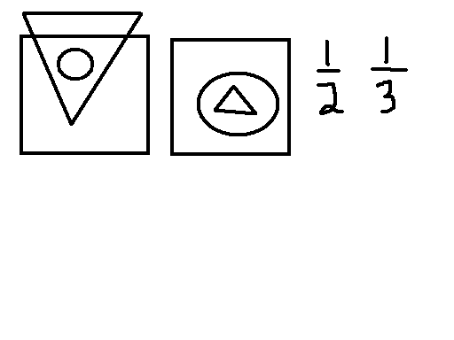
Vowels:_____________________

blast off
Name: ___________________ Date: _________________

b g h q l r d p h b

12 10 13 14 16 18 19

hop ropes cat cakes do

see seed feed need to

I ate the big banana.

4 9 6 5 3
+8 +3 +6 - 2 -3

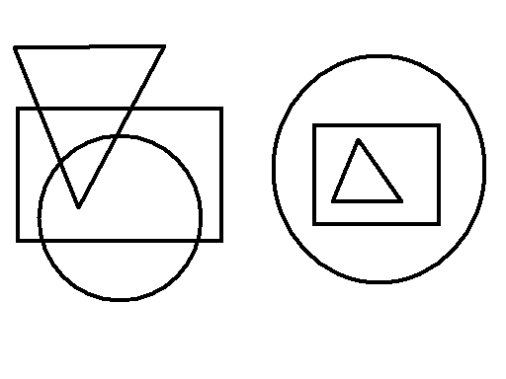
Vowels:_____________________

blast off
Name: ___________________ Date: _________________

b l g r n q d h D B f p

keep peep steep me he

to do home kite bone

fat cat

I can eat the cake and the apple.

6 7 5 4 9
+4 +3 +5 -1 - 3

12 14 17 8 18 10 13 11

Vowels:_____________________

blast off
Name: ___________________ Date: _________________

p d b q g l f h r n u v

hop pop hope

safe cake eat

I want to pet the fat cat

6 8 12 9 11 15 17 18

6 7 5 4 9
+4 +3 +5 -1 - 3

Vowels:_____________________

blast off
Name: ___________________ Date: _________________

p d b q g h l f r n u

I want to go to the toy store to get lots of toys.

4 12 6 10
+5 +3 -2 - 3

1 1 1 1 14
2 3 4 5

Vowels:_____________________

blast off
Name: ___________________ Date: _________________

a e i o u h j w x p b

like hike bike rope

The cat sat on a hill and said, “Meow.” The cat ate a big rat. Yum!

2 9 5 4 10
+4 +2 +7 -1 - 3

Vowels:_____________________

blast off
Name: ___________________ Date: _________________

b x p g l h q r o i

cake hope hat toy

I am a big cat and I want to eat the dog.

2 6 8 6
+5 +3 -4 - 1

Vowels:_____________________

blast off
Name: ___________________ Date: _________________

6 11 18 13 12 19 17

15 16 14 1 10 23 25

sink part hill bug

The big girl can ride her bike very well!

2 9 6 8
+7 +5 -3 - 8

Vowels:_____________________

blast off
Name: ___________________ Date: _________________

c d f B F g j H x

k l p q b s v r w

say play stay day

toy boy tape want

I want to see the dog bite the rat on his tail.

2 4 3 5
+6 +8 -3 - 3

Vowels:_____________________

blast off
Name: ___________________ Date: _________________

24 26 29 14 18 17

11 12 10 22 20 21

sink pink stop last

make coke like tame

Sam is a big girl.

6 4 5 5
+6 +4 +5 - 5

Vowels:_____________________

blast off
Name: ___________________ Date: _________________

18 26 23 14 27 19 10 12 11 22 21 20

pot spot top stop

tap tape hop hope

I can see the big cat.

3 6 5 8
+4 +5 -1 - 8

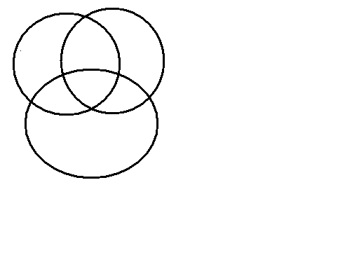
Vowels:_____________________

blast off
Name: ___________________ Date: _________________

12 8 14 18 23 25 20 15

17 21 10 24 11

seed feed tree sky

I am the best girl on the cul-de-sac.

6 3 5 23
+7 +8 -2 - 23

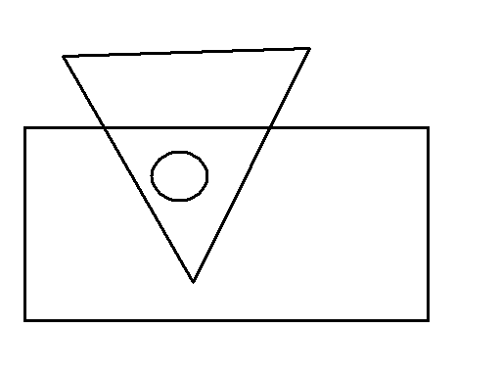
Vowels:_____________________

blast off
Name: ___________________ Date: _________________

18 14 23 12 27 10 22

20 11 19 13 15 28 1

fast last list stop

The cat was mad. He ate the dog.

6 2 4 8
+8 +1 -3 - 2

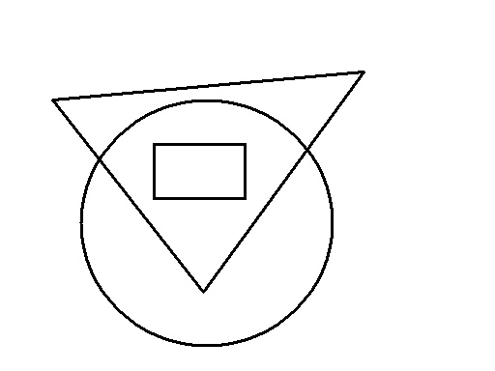
Vowels:_____________________

blast off
Name: ___________________ Date: _________________

27 19 20 12 11 15 18

24 13 26 16 10 23 21

sink pink wink bat

sing ring king wing

The girl hit the ball with the bat.

6 9 5 6
+7 +3 -1 - 3

Vowels:_____________________

blast off
Name: ___________________ Date: _________________

16 21 20 19 23 4 10 18

12 13 22 15 10 25 27

keep seed feed need

sent bent went tent

I like to go to the place where the swings are.

6 7 10 5
+6 +7 -2 - 3

Vowels:_____________________

blast off
Name: ___________________ Date: _________________

26 13 10 12 21 14 11 19 15 100 25

31 34 36 27 lip slip flip lips

talk walk sulk milk

The little girl did not drink her milk.
⅓

12 16 13 5
+4 + 3 -4 - 1

Vowels:_____________________

blast off
Name: ___________________ Date: _________________

29 16 29 12 22 10 31 18 24 11 20

35 32 30 4 nose hose rose cake

milk tank sink pink

I want to see the dog that ate the bug.
¼

15 6 4 10 12
+3 + 7 -2 -10 -4

Vowels:_____________________

blast off
Name: ___________________ Date: _________________

4 12 26 17 19 30 11 10 20 r e b

g l h i q j x k n u d

hair rain pair tail

Can you please get me a cup of milk? I am thirsty.

½
2 9 6 4 12 3
+3 + 4 +6 -1 -3 -3

Vowels:_____________________

blast off

Name: ___________________ Date: _________________

b p q r a

11 24 36 14

cat hope eat

I am Sam.

2 3
+4 -1

Vowels:_____________________

blast off
Name: ___________________ Date: _________________

14 36 27 18 23 11 10 20 31 r g l

i q v p r n b d p h

run fun sun bun hate

I like to play with Kevin and Kara.

⅓
7 8 6 9 1 8
+3 + 0 +5 -2 -0 -8

Vowels:_____________________

blast off
Name: ___________________ Date: _________________

P l g r s p d h p b

28 13 10 20 35 15 34 clam close
click talk walk sulk milk

The boy said, “Stop! Do not hit the cat!”
½

4 12 8 4
+7 + 6 -3 - 1

Vowels:_____________________

blast off
Name: ___________________ Date: _________________

x p l g r t p v d n u b

p slip slap slow sloppy

34 19 25 13 20 15 41 43

The little girl said, “Mom, can I go to Kara’s to play?”

8 9 3 12
+7 + 3 -2 - 3

Vowels:_____________________

blast off
Name: ___________________ Date: _________________

p b d h f l g q p j

42 44 33 20 13 16 40

pay play say stay day

I want to play with Kara.
½

4 9 3 19
+8 + 6 -2 - 3

Vowels:_____________________

blast off
Name: ___________________ Date: _________________

p r g q p d b 6

23 46 37 18 3 10 50 40 30

running hitting sitting kicking

The small girl was very nice.
¼

10 12 18 4
+11 +14 -2 - 2

Vowels:_____________________

blast off
Name: ___________________ Date: _________________

g p h d b p q

47 49 52 10 54 38 24 12 66

cook book hook look

Roses are red,
Violets are blue,
Butterflies are pretty,
And so are you.

16 16 2 5
+ 4 +13 -1 - 3

Vowels:_____________________

blast off
Name: ___________________ Date: _________________

p b d q l r g

47 92 83 14 21 35 75

slip stop smoke stay

I want to be a duck when I grow up.

2 16 4 8
+ 7 +13 -3 - 8

Vowels:_____________________

blast off
Name: ___________________ Date: _________________

p l d g r p b q

16 28 49 36 51 13 11 62

pair hair stairs chair

I dare you to cut your hair.

14 14 11 2
+3 +13 -4 - 2

red blue green yellow
½ ⅓ ¼
Vowels:_____________________

blast off
Name: ___________________ Date: _________________

p h l r g f b d

64 93 87 74 51 40 32 21

boat float coat goat

I hope I can see a goat.

8 12 4 8
+ 9 +12 -2 - 2

Vowels:_____________________

blast off
Name: ___________________ Date: _________________

p d l h g f b

14 10 21 36 88 91 70 100

sink pink think

I will eat the hot dog.

8 12 2 8
+ 5 +12 -0 - 8

Vowels:_____________________

blast off
Name: ___________________ Date: _________________

p q l r g h b d

26 100 93 15 13 30 47

feet seeds heat keep

I have two feet.

4 12 3 5 0
+ 9 +13 -1 - 2 -0

Vowels:_____________________

blast off
Name: ___________________ Date: _________________

p t l r g m v j

sand hand land

How now brown cow?

6 12 4 3
+ 8 +15 -1 - 3

Vowels:_____________________

blast off
Name: ___________________ Date: _________________

p h l r g q b d j

16 93 40 57 21 32 12

sing king ring thing

I hope I can see a goat.

4 9 2 8
+ 3 +2 -2 - 3

Vowels:_____________________

blast off

Name: ___________________ Date: _________________

stop stamp stick pink

28 30 84 73 13 46 67

rabbit little giggle wiggle

The little girl said to her mother, “Mom, will I be a duck when I get big?” The Mom said, “Quack, quack.”

6 9 3 7
+ 1 +4 -1 - 5

Vowels:_____________________

blast off

Name: ___________________ Date: _________________

r k x u a a i p

10 23 12 87 100 21 93 101 15

snake slide sneak

I want to go to the playground. I will slide, and swing, and play in the sand.

8 2 10 4
+ 4 +3 -3 - 4

Vowels:_____________________

blast off

Name: ___________________ Date: _________________

d q j x n k b a p

21 12

100 23 51 104 39 110

plate clap sent broke

8 13 9 16
+ 4 +24 -3 - 2

The long car drove by while I was going to the toy store.

½
⅓

Vowels:_____________________

blast off
Name: ___________________ Date: _________________

p d b l q h g k r w

16 91 101 110 100 25 12 110

sky try fly cry sun

8 22 9 14
+ 3 +21 -1 - 3

I like to read books about firemen.

Vowels:_____________________

blast off

Name: ___________________ Date: _________________

p f l q D B k r

29 103 81 111 12 200

[Your child should read an easy book aloud]

I am a big girl.

14 3 2 8
+13 +9 -2 - 3

½

Vowels:_____________________

blast off
Name: ___________________ Date: _________________

g r v x k Q d F b G p

16 11 31 12 21 13 115 121

At Halloween, the air is full of witches, and the pumpkins smile at you.

16 7 9 14 ⅓ 1
+12 +7 -1 - 3 5

½

Vowels:_____________________

blast off

Name: ___________________ Date: _________________

F Q P B S t u v m

My name is Sammy.

34 76 201 210 131 26 45

5 6 4 6 4
+4 +4 +4 - 4 -4

½
⅓
¼

Vowels:_____________________

blast off

Name: ___________________ Date: _________________

r x u a p l t m d v b

14 27 61 21 11 104 123

sick stick pick kick

The little girl said, “Go home, you bad cat. Do not poop in my yard!”.

6 21 18 9
+ 9 +34 -2 - 5

Vowels:_____________________

blast off

Name: ___________________ Date: _________________

s k x t o a l d b p h r

v u w 19 21 12 13 111 104 122

146 191 200

might right sight fight tight

24 9 2 33 4
+34 +8 +1 -21 - 4

I might go to the new school to see the ball game.
2
5
1
5
½ ⅓ ¼

Vowels:_____________________

blast off

Name: ___________________ Date: _________________

Word: _____________________

196 29 121 104 203

hop hope smoke fire

The little girl said, “Fire!” when she saw the smoke.

6 23 38 55 26 9
+ 7 +34 -24 +23 - 16 +6

Vowels:_____________________

blast off

Name: ___________________ Date: _________________

Word: _____________________

x l b d h n v u p

93 26 41 3 102 121 164

happen rotten butter

The nice little girl took the dog for a walk.

1 23 0 4 9
+ 4 +31 -0 - 2 +8

Vowels:_____________________

blast off

Name: ___________________ Date: _________________

Favorite Food: _____________________

26 126 31 131 94 294

smoke snake spoon shy

0 1 2 3 4 5 6 7 8 9 α β

10’s | 1’s |  | 10’s | 1’s |  | 100’s | 10’s | 1’s

Vowels:_____________________

blast off

Name: ___________________ Date: _________________

Favorite Brother: _____________________

x l b d n v u p q l k f

91 23 143 6 103 21 112

happy silly goofy funny

I want to go to see a movie.

3 18 10 4 9
+ 4 +11 -3 - 2 +5

Hard word: __________________________

Vowels:_____________________

blast off

Name: ___________________ Date: _________________

Mom’s Name: _____________________

A B a b C D c d P Q p q

I am a big girl now.

3 10 7 6
+ 4 +21 -3 - 2

Vowels:_____________________

blast off

Name: ___________________ Date: _________________

Favorite Word: _____________________

g l b d n v u p q l k f

r j 61 202 493 113 21 12

see to go me he be

The tall girl went to her school and played games.

9 16 13 4
+ 7 +13 -4 - 2

Vowels:_____________________

blast off

Name: ___________________ Date: _________________

Word: _____________________

p q l h d b r y j

19 84 73 102 232

hat take boat coat

I took the book to school.

14 16 8 9
+ 1 +23 -3 - 9

Vowels:_____________________

blast off

Name: ___________________ Date: _________________

Favorite Boy: _____________________

p l q j k x h d b

214 931 101 63 13 10

hoop poop cook book

The big dog said, “Roof!”

6 11 8 6 18
+ 3 +14 -8 - 2 +14

Vowels:_____________________

blast off

Name: ___________________ Date: _________________

Favorite Animal: _____________________

p d b j q g

266 923 86 101 47

carrot apple lemon chicken

I ate a turkey sandwich for lunch.

16 18 3 8
+ 16 +12 -3 - 2

Vowels:_____________________

blast off

Name: ___________________ Date: _________________

Favorite Animal: _____________________

j k q h g d p b

293 13 21 12 800 121

want talk shop sink

I want to eat hamburgers for dinner.

16 Place System: 123 920 816
+24

Vowels:_____________________

blast off

Name: ___________________ Date: _________________

Favorite Fruit: _____________________

p d l v x r z n u

K r o n s t a d t

112 26 19 13 301 47

hand want slot pants

I can draw a heart for my Valentine’s Day card.

19 14 6 8
+ 12 +23 -4 - 2

Vowels:_____________________

blast off

Name: ___________________ Date: _________________

Age: _______

A a a B b C c D d P p

Q q G g

121 262 12 135 13

(Ask your child to write in the word “not” in the space provided if she wants)

I am Sammy.

8 18 5 3 1
+ 12 +23 -4 - 3 +1

path port part

Vowels:_____________________

blast off
Name: ___________________ Date: _________________

Favorite Animal: _____________________

212 63 903 400 361

octopus snake lizard alligator

The little girl was such a good reader, children came from all around to hear her read. After she finished reading a long story, they proclaimed her the “Queen of Light and Air.”

19 6 6 8
+ 24 +8 -4 - 3

Vowels:_____________________

blast off

Name: ___________________ Date: _________________

skate break talk

193 266 480 12 300

“When you are hot, you are hot!”

26 3 26 11
+15 +19 -14 - 3

½

Vowels:_____________________

blast off

Name: ___________________ Date: _________________

720 912 113 64 212

crawling trying seeing driving

266 8 29 4 872
+345 +7 -12 - 3 - 0

If I can, I want to be a singer when I grow up.

Fractions: ½ ⅓ ¼ ⅔

Vowels:_____________________

blast off

Name: ___________________ Date: _________________

skunk stamp help

169 301 412

569 8 10 49
+453 +7 - 2 - 21

I have three sisters and one brother. I also have two puppies.

Fractions:

1
5
3
2
2
3
1
4
1
9

Vowels:_____________________

blast off

Name: ___________________ Date: _________________

helping kissing seeing being

801 916 330 47 111

The boy wanted to see a movie, but the girl wanted to eat out at Eat-n-Park. Guess who won?

69 69 19 27
+24 +31 - 4 - 0

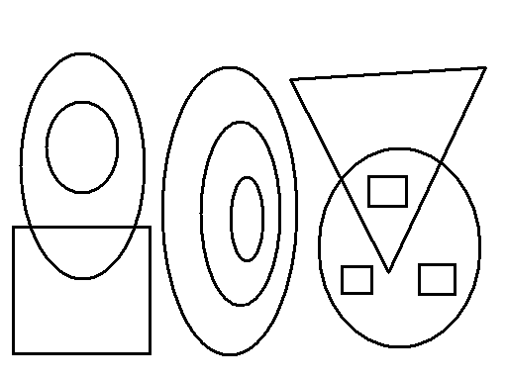

Vowels:_____________________

blast off
Name: ___________________ Date: _________________

hard complain sting

191 363 1,001 400

Now that I am five, I can chew gum!

96 4 7 64
+25 +9 - 2 - 31

Fractions:
1
5
3
2
2
3
9
10
6
7

Vowels:_____________________

blast off

Name: ___________________ Date: _________________

soap keep taste bringing

163 200 47 21 2,001

Once upon a time there was a beautiful princess who was in love with a frog. Fortunately, she married a prince instead.

39 6 86 5
+ 82 +5 -25 - 3

Vowels:_____________________

blast off

Name: ___________________ Date: _________________

wash bush wish fish

186 901 1,216 483

The little girl said, “When can I go play with my friend Kara?”

18 96 6 26
+ 44 +25 -3 - 13

Multiplication: 2 ∙ 3 = ________
2 x 3 = ________
2 x 4 = ________
3 x 2 = ________

Vowels:_____________________

blast off

Name: ___________________ Date: _________________

chicken cheese cheap chip

811 2,012 1,106 480

Today is a good day because Sammy and Kara both go to Friday Fun. Then, Sammy has a birthday party.

89 194 11 464
+ 34 +266 -3 - 223

2 ∙ 4 = ___ 3 ∙ 4 = ___ 4 ∙ 2 = ________

1
2
3
4
2
3
1
10

Vowels:_____________________

blast off

Name: ___________________ Date: _________________

house peace race face

899 2,201 460

My favorite band is the Beatles.

2 196 4 86
+ 1 +315 -0 - 23

2 ∙ 1 = ___ 2 3
x 2 x 1
3 x 2 = ___

Vowels:_____________________

blast off

Name: ___________________ Date: _________________

tiger lion leopard jaguar

803 1,214 3,632 10,000

When I am thirty, I want to be a doctor and have two children (a boy and a girl).

BORROWING!!! NEW!!

84 3 50 31
+37 +1 -12 - 12

2 ∙ 2 = ___ 3 3
x 2 x 1

Vowels:_____________________

blast off

Name: ___________________ Date: _________________

160 2,381 1,009 48

castle whistle dragon sword

18 1 81 20
+ 43 +1 -13 - 3

The mighty dragon roared and breathed fire.

2 ∙ 4 = ___ 3 ∙ 1 = ___ 2
x 2

1
2
1
54
1
3
1
10

Vowels:_____________________

blast off

Name: ___________________ Date: _________________

443 3,201 60 902

sinking feeling seeing being hitting

84 96 43 81 3
+ 21 +15 -11 - 14 -2

Bye, bye Miss American Pie. Drove the Chevy to the levee but the levee was dry.

1
4
3
24
2
3
1
10

Vowels:_____________________

blast off
Name: ___________________ Date: _________________

3,333 101 110

time mime lime bye

Read Book!

5 25 120 13 6
+ 6 + 6 - 18 +12 -3

1
4
_
_
_

2 ∙ 2 = ____ 2 ∙ 3 = ____

Vowels:_____________________

blast off

Name: ___________________ Date: _________________

g q k x p l d b r v

tell bell heat heart cry

619 2,401 3,001 200

Math is very fun, but reading stories is even more fun!

23 96 41 90
- 4 +15 -22 - 16

1 ∙ 5 = ___ 4 2
x 2 x 4
2 x 3 = ___

3 x 2 = ___

Vowels:_____________________

blast off

Name: ___________________ Date: _________________

649 2,318 1,001 204

[Pick a book and read from it.]

4 27 41 83 6
- 0 +49 -22 - 61 +8

Last night I had the strangest dream I ever dreamed before. I dreamed the world had all agreed to put an end to war.

3 ∙ 2 = ___ 5 x 2 =

2 x 4 = ___ 2 x 5 =

Vowels:_____________________

blast off

Name: ___________________ Date: _________________

93 2,417 2,012

[Pick a book and read from it.]

car far party

81 93 42 63
- 14 +18 +21 - 12

3 ∙ 3 = ___ 5 x 3 =

2 x 4 = ___

Vowels:_____________________

blast off
Name: ___________________ Date: _________________

300 2,222 1,091 406

[Pick a book and read from it.]

runner hitter singer eater

19 27 41 86
- 7 +39 +41 - 23

Roses are red,
Violets are blue,
Tommy is nice,
And so are you.

3 ∙ 5 = ___ 2 x 6 =

Vowels:_____________________

blast off

Name: ___________________ Date: _________________

5,219 301 4,007

[Pick a book and read from it.]

high sigh tight night fight

14 13 695 81
- 6 +28 +436 - 15

2 6 9 4 9
- 0 +4 +3 - 3 - 3

3 ∙ 3 = ___ 2 x 5 =

Vowels:_____________________

blast off
Name: ___________________ Date: _________________

630 912 2,002 4,030

[Pick a book and read from it.]

bottle piglet high sight

13 6 69
+ 4 +8 +21

The pretty girl said, “How high can you jump?”

“R” practice: run red rag
her car sore
girl

Vowels:_____________________

blast off

Name: ___________________ Date: _________________

6,496 283 10,306 201

blocks talk help thin

28 6 28 41
-12 - 4 +24 -13

The puppies are very frisky in the morning!

More “R” practice:

car curl red far

2 ∙ 3 = ___ 3 4
x 1 x 2

Vowels:_____________________

blast off

Name: ___________________ Date: _________________

621 1,390 11,401 701

car her singer truck girl

97 4 28 41 3
+64 - 1 +24 -13 +8

The little girl asked her father, “What will I be when I grow up?”

2 x 6 = ___ 3 4
x 2 x 1

Vowels:_____________________

blast off

Name: ___________________ Date: _________________

281 6,911 12,302 47

bump crowd clever clown

Addition:

86 9 12 8 2
+45 +1 +13 +6 +1

I like school, but I miss the dogs while I am away.

Run red girl her car

Vowels:_____________________

blast off
Name: ___________________ Date: _________________

849 2,319 12,222 1,001

far her run tiger girl hurt

4 21 63 63 12 1
- 2 - 10 +19 - 19 +7 +2

What do you want? Who is she? Where are we going? Why? When will we get there?

3 ∙ 3 = ___ 5 x 2 =

3 x 5 = ___

Vowels:_____________________

blast off
Name: ___________________ Date: _________________

1,234 13,001 410 6,030

runner trying clap stink

4 16 18 24
+3 +16 + 1 + 1

I was sleeping last night when I heard a bump in the basement.

Star her girl far tiger

Vowels:_____________________

blast off
Name: ___________________ Date: _________________

23,202 14 900 813

simple clock track snip

11 36 2 14 38
+ 1 + 1 +9 +22 +16

Hey! You kids! Stop all that noise! Your mother is trying to sleep!

3 3 4 10 0
x 2 x 1 x 2 x 1 x 4

Vowels:_____________________

blast off

Name: ___________________ Date: _________________

24,912 16,011 280 301

skunk creature light night

2 13 28 8
+7 + 1 +19 +2

All through the night, the goblins and ghosts were acting very scary.

9 6 21 41
-1 - 3 - 10 -15

cube parabola cylinder rectangular prism

blast off

Count by 5’s
SPECIAL WORKSHEET

Name: ___________________ Date: _________________

One-Dimensional Shapes (look like strings):

Two-Dimensional Shapes (can paste on wall or color inside):

Three-Dimensional Shapes (cannot paste on wall; maybe can hold water):

Name: ___________________ Date: _________________

124,261 80 901 2,000

street fight running tight

26 3 24
+ 1 +1 +19

When I grow up, I want to be a teacher and a mother.

10 8 26 71
- 1 - 4 - 14 -13

Vowels:_____________________

blast off

Name: ___________________ Date: _________________

6,402 13 216,391 001

fur far fir for four her girl

217 9 37 4
+384 +6 + 1 +4

Where will we go? What will we do? Will we be happy? Will they give us a pretzel?

13 2 4 22
- 9 - 1 -2 -14

Vowels:_____________________

blast off
Name: ___________________ Date: _________________

284 12,901 123,600 1,040

fight sigh tight right high

car her turn girl fur

46 89 91 3
- 21 +16 - 34 +9

3 ∙ 3 = ___ 4 8
x 2 x 1
2 x 5 = ___

Read a book!

Vowels:_____________________

blast off
Name: ___________________ Date: _________________

209 60,010 483,216 1,040

castle whistle pickle wrinkle

tire her car four pair

38 49 91 6 8
- 14 +86 - 26 +7 -0

3 ∙ 4 = ___ 10 ∙ 2 = ___

5 x 3 = ___ 9 ∙ 2 = ___

Read a book!

Vowels:_____________________

blast off
Name: ___________________ Date: _________________

97,401 201,030 390 1,063

Practice “r” words

Addition flash cards

93 28 81 68
- 41 +37 - 39 +21

3 ∙ 6 = ___ 23 34
x 2 x 2

Read a book!

Vowels:_____________________

blast off
Name: ___________________ Date: _________________

32,103 111,111 1,000,000 60

right write rite action

Addition flash cards

91 28 101 286
- 16 +35 - 86 +395

car her red Kara girl

Read a book!

Vowels:_____________________

blast off

Name: ___________________ Date: _________________

29,001 100,010 2,000,311 14

103 2 869 4
- 64 +5 +348 +5

23 34 12
x 2 x 2 x 3

Read a book!

Vowels:_____________________

blast off
Name: ___________________ Date: _________________

2,861,342 200,302

2
3
1
44
3
7
1
2

girl her fur car pure fire bear

203 28 39 222
-126 +14 +21 - 134

25 31 26 43
x 2 x 3 x 2 x 3

Read a book!

Vowels:_____________________

blast off
Name: ___________________ Date: _________________

2,163 110,901 431,262 12

hunt hurt help hand

26 9 46 8
+13 +5 +19 +8

Who says that boys are better? I think girls are better (except for Tommy).

Vowels:_____________________

blast off
Name: ___________________ Date: _________________

27 912 123,208 401,203

saddle crunch chuckle print

14 27 8 91 18
- 6 +36 +7 - 15 - 9

Read a book!

Vowels:_____________________

blast off
Name: ___________________ Date: _________________

3,603 92,002 179,617 31

cracker handed swept we

6 23 8 81 14
- 3 +12 +6 - 13 - 5

Read a book!

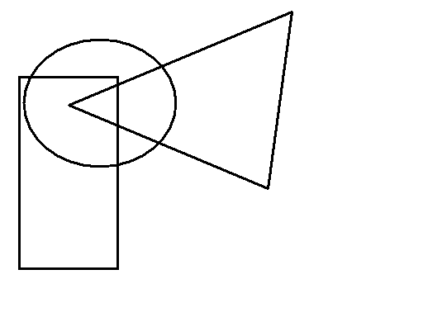

Vowels:_____________________

blast off
Name: ___________________ Date: _________________

29,020 11,265 10,003

sprinkler walking creaky fox

9 26 8 83
- 3 +44 +8 - 15

3 ∙ 2 = ___ 8 ∙ 2 = ___

5 x 2 = ___ 7 ∙ 1 = ___

Read a book!

Line Ray Line Segment

Vowels:_____________________

blast off
Name: ___________________ Date: _________________

28 2,401 101,001 12

pebble straw paste ankle

2 26 19 41 6
- 1 +48 +11 - 14 +8

2 ∙ 3 = ___ 4 ∙ 2 = ___

3 x 1 = ___ 3 ∙ 3 = ___

Read a book!

Line Ray Line Segment

Vowels:_____________________

blast off
Name: ___________________ Date: _________________

2,600 193,111 47 2/5

strike clear proud smile

7 98 62 18 9
- 1 +15 - 15 - 6 +8

Read a book!

Line Ray Line Segment

Angles:

Vowels:_____________________

blast off
Name: ___________________ Date: _________________

29,666 181,001 430,200

stink creek march giggle

8 19 61 12 4
- 2 +14 - 13 + 3 +4

2 ∙ 3 = ___ 6 ∙ 1 = ___ 3 x 3 = ___

2 ∙ 5 = ___ 3 x 4 = ___ 8 ∙ 0 = ___

Read a book!

Angle
Ray
Line Segment
Line
Vowels:_____________________

blast off
Name: ___________________ Date: _________________

18,029 1,000,000 261,403

gallop crumble freckle peace

though through tough cough play

9 8 29 18 0 26
- 3 +8 - 13 +19 +4 -17

0 ∙ 3 = ___ 4 ∙ 3 = ___ 2 x 3 = ___

5 ∙ 3 = ___ 9 x 1 = ___ 10 ∙ 2 = ___

8 ∙ 2 = ___ 1 ∙ 1 = ___

Read a book!

Vowels:_____________________

blast off
Name: ___________________ Date: _________________

2
3
1
44
3
6
1
2
8
9
4
11

fur hurt curl word dirt

Read a book!

803 958 ½ + ½ = ____
-215 +675

2
3
4
74
1
3
6
7
+
+
=
=

23 14 23
x 3 x 2 x 2

Vowels:_____________________

blast off
Name: ___________________ Date: _________________

2
3
1
44
9
10
16
21
8
100
31
50

her curl burn car far fire

216 189 401
- 37 +396 - 98

2
2
1
34
3
2
2
3
+
+
=
=

24 33 12 15
x 2 x 3 x 3 x 2

Vowels:_____________________

blast off

Name: ___________________ Date: _________________

2
3
1
44
3
20
1
2
4
7

far car care hurt girl

328 404 88
-149 +128 +16

23 25 12 15
x 4 x 2 x 3 x 2

Read a chapter book!

Vowels:_____________________

blast off

Name: ___________________ Date: _________________

2
7
1
44
1
2

386,429 1,000,021

curve hurt girl her far

803 968 26 900
-247 +347 +55 -634

21 35 43 61
x 2 x 2 x 3 x 2

Read a chapter book!

Vowels:_____________________

blast off

Name: ___________________ Date: _________________

2
3
1
44
1
2

32,068 1,020,010

Read a chapter book!

tire her growl curl cure

64 286 803
- 23 +947 - 281

2 ∙ 3 = ___ 10 ∙ 3 = ___ 4 x 3 = ___

6 ∙ 2 = ___ 8 x 1 = ___ 10 ∙ 0 = ___

25 78 4 ÷ 2 =
x 3 x 2 6 ÷ 2 =
8 ÷ 2 =
6 ÷ 1 =

Vowels:_____________________

blast off
Name: ___________________ Date: _________________

2
7
3
84
1
2

1,063 20,010 1,000,010

curl world pure tire bore

100 29 212
- 21 +84 - 34

1
2
1
44
1
2
3
4
+
+
=
=
1
2
4
54
2
3
5
5
+
+
=
=

28 4 ÷ 2 = $2|\overline{6}$
x 2 9 ÷ 3 = ‌
8 ÷ 2 =

Vowels:_____________________

blast off
Name: ___________________ Date: _________________

2
7
9
314

28,604 1,201,310

hard word fur star fire

Read a chapter book!

401 89 48 877
-246 +31 - 23 +928

14 12 2 x 3 = $3|\overline{6}$
x 3 x 2 4 x 2 = ‌ 8 ÷ 4 =

$\frac{4}{2}=$$\frac{9}{3}=$
Vowels:_____________________

blast off
Name: ___________________ Date: _________________

2
5
19
224

20,030 3,403,062

hard word bird clobber

Read a chapter book!

2
3
1
44
3
3
2
5
+
+
=
=

213 396
-184 +148

15 12 $2|\overline{\text{10}}$ $4|\overline{8}$
x 3 x 3 ‌

Vowels:_____________________

blast off

Name: ___________________ Date: _________________

2
9
31
434

18,603 2,000,201 156

harbor cranium cradle crater

Read a chapter book!

203 28 48 19 2
- 67 +36 - 19 + 4 +8

15 12 2 ∙ 3 = $9|\overline{\text{18}}$
x 4 x 4 4 x 5 = ‌
$\frac{\text{12}}{6}=$ 6 x 2 = 6 ÷ 3 =

Vowels:_____________________

blast off
Name: ___________________ Date: _________________

2
8
3
9

1,021,964 28,032

harp crude pure try iron

Read a chapter book!

603 25 213 286
-214 +38 - 87 +965

$6|\overline{\text{12}}$ 9 ÷ 3 = 8 ÷ 2 =

37 14 8 15
x 3 x 2 x 2 x 3 ‌

Vowels:_____________________

blast off
Name: ___________________ Date: _________________

3
4
1
2
9
10

2,001 1,092,612

cart strap pearl lurk brick

43 29 213 987
-21 +68 - 87 +346

$2|\overline{6}$ 8 ÷ 2 =
$\frac{9}{3}=$$\frac{\text{12}}{6}=$

9 29 30 24
x 3 x 3 x 3 x12 ‌

Vowels:_____________________

blast off
Name: ___________________ Date: _________________

1
4
1
2
31
32

2,863,902 24,603

603 213 897
-124 -47 +689

$2|\overline{4}$ $1|\overline{8}$ $3|\overline{0}$ 6 ÷ 2 =
$\frac{9}{3}=$$\frac{8}{4}=$$\frac{4}{2}=$

31 28 35 24
x12 x 2 x 3 x13 ‌

Read Chapter Book!
Vowels:_____________________

blast off
Name: ___________________ Date: _________________

1
2
23
43

1,091,063 48

car her fur cure puree fewer

903 812 189
-421 -629 +286

$4|\overline{\text{12}}$ $4|\overline{\text{16}}$ $3|\overline{\text{12}}$ $2|\overline{\text{10}}$

29 38 2 ∙ 6 = ____
x12 x 3 ‌
1
2
3
2
+
=

Vowels:_____________________

blast off

APPENDIX A

SAMPLE HOMEWORKS

